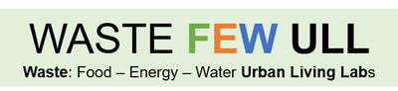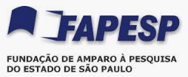

FAPESP/Belmont Forum - Sustainable Urban Global Initiative
São Paulo In Natura Lab
Ester Dal Poz

Workshops 1 and 2 – WP6 of Waste FEW ULL Project

Co-creation and testing of a replicable decision support tool for practice across geopolitical and cultural boundaries.

This document illustrates the two separated workshops performed by Sao Paulo ULL, concerning the WP6 work package – Replicable Models for ULLs (Rotterdam group).
The audience was:
- Workshop 1: policy makers and food production technical assistance of the Sao Paulo City Secretary of Agriculture and Food Supply; these actors are partners of Sao Paulo ULL, and have been deeply involved in practical actions and policy making activities: a) agroecological transition activities in food production, in green belt megametropolis regions – South and East and b) waste-inefficiencies, reducing and managing urban waste, both in terms of biological, recyclable and non-recyclable material from the 850 street fairs (weekly), big food hubs and supermarkets and c) food banks organized by governmental actors, private actors and producers.
- Workshop 2: academic actors (from Master to pos doctoral and university professors) from Food Losses and Waste topics.
Analysis of the decision making tree and application of the questionnaire were carried out on February 2021.

Workshop 1 - 02/18/21

The “decision-tree was presented for the participants, in order to have a common ground comprehension about its rationale.
Then, each of the 6 questions were discussed and reported.

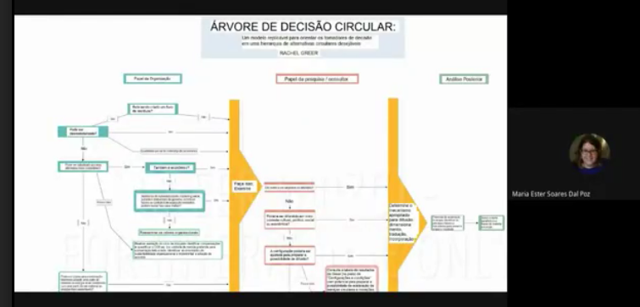
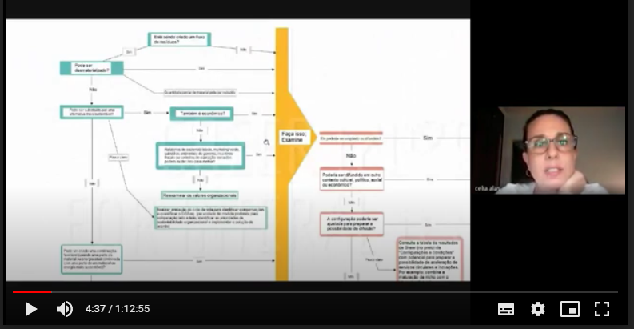
Celia Alas, from The City of São Paulo Food and Supply Secretary, Coordinator of SP Food Bank

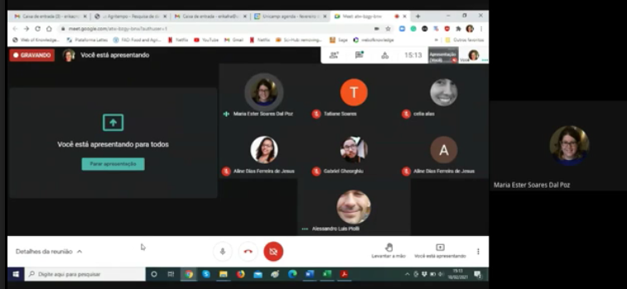
Workshop participants screen.
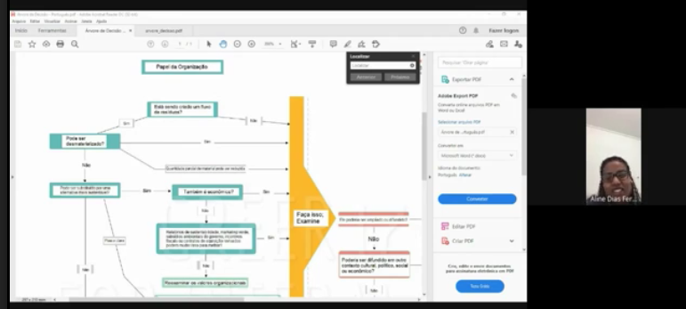
Aline Ferreira, from The City of São Paulo Food and Supply Secretary , coordinator fo Agroecological Transition.

Workshop 2 - 02/23/2021
The same procedure was adopted for this workshop.

Alessandro Piolli, Post Doc Researcher of São Paulo ULL, presenting the decision tree.
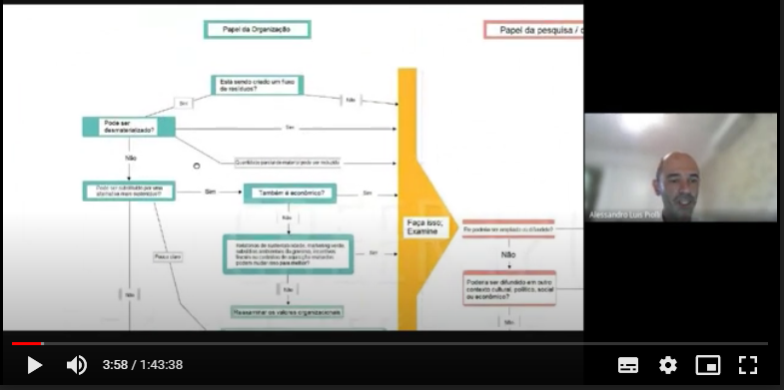
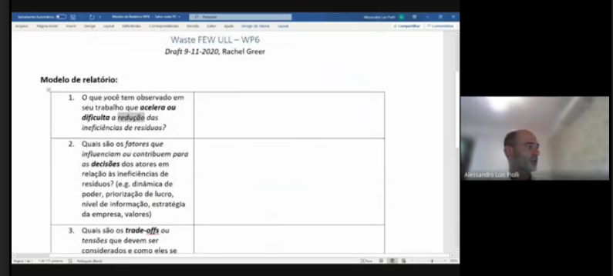
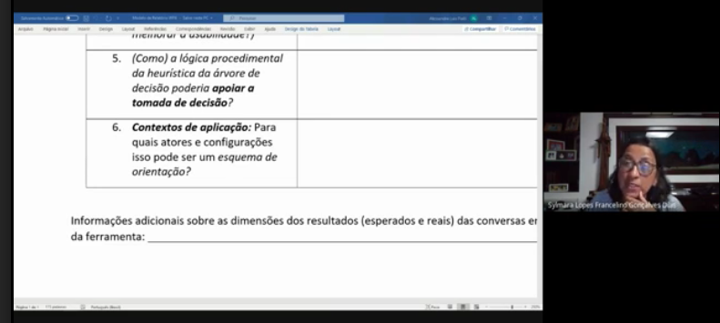
Professor Sylmara Gonçalves Dias, from University of São Paulo, discussing the questionnaire.

