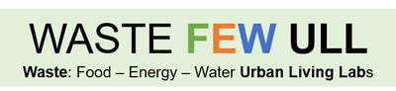

São Paulo Urban Living Lab – ULL
Brazil

FAPESP/Belmont Forum
Sustainable Urban Global Initiative

Ester Dal Poz
UNICAMP

Updating - Results of the work carried out between September, 2018 and March, 2019

- Pipeline

The Project pipeline is focused on “water-food” nexus; the “energy” nexus will be considered as a proxy.
Of course, we are dealing wity transition theories and governance, so, the Project has been putting efforts at those academic areas.
We have 3 action situations to take care: the ULL institutionality pattern, once it is a locus for sustainability governance; and – as the Project proposal points, two other objetives: to map dysfuncionalities and to propose reduction os the nexus problematic systems.

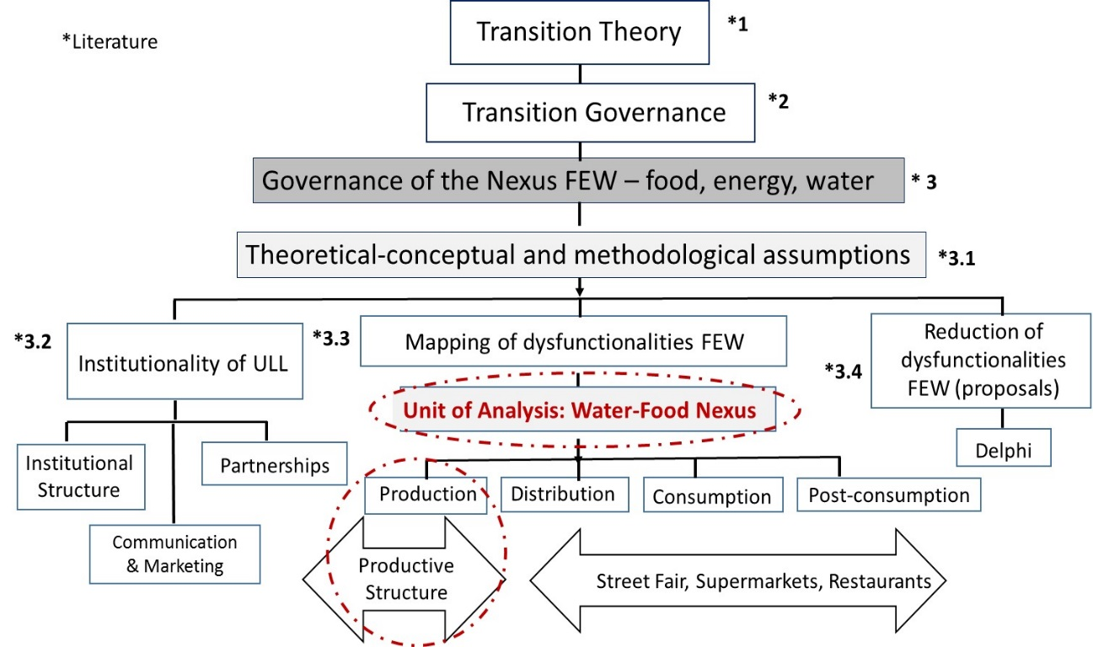

Figure 1. São Paulo ULL Pipeline; focus on productive structure nexus.

- Sao Paulo City Regions of Research
Three regions of the São Paulo metropolitan area will be considered for field work: Ibiuna, Mogi das Cruzes and Parelheiros, as seen at Figure 2.; note that all of them are close to big water lock-gates areas:

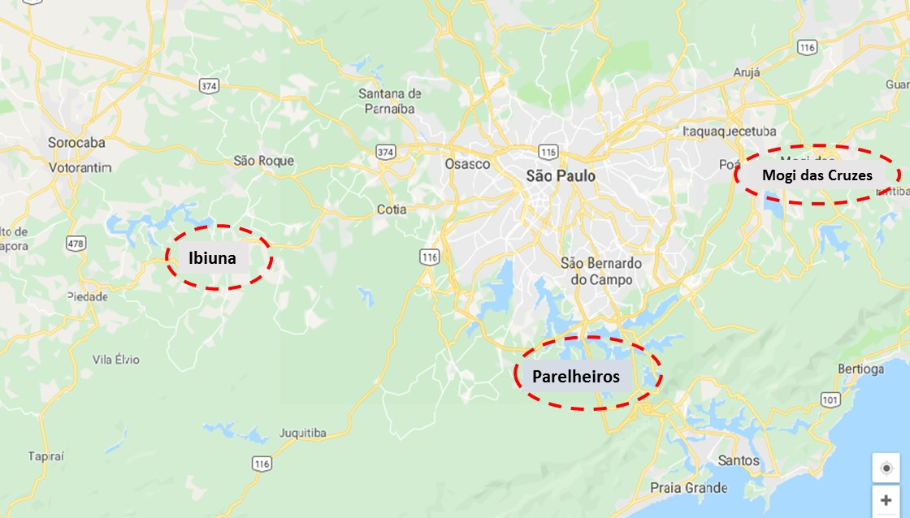
Figure 2. Sao Paulo metropolitan area – with Ibiuna, Parelheiros and Mogi das Cruzes food production locations.

- Actions concerning partners and stakeholders
Mogi das Cruzes
- Sabesp Meetings, the São Paulo State Water and Sewage Co., main partner of the Belmont Forum proposal: a) February/19, for data base and field work (water-food nexus), and b) to make decisions about regions of research, stakeholders and methodologies; meeting (March/19) for water-food “causal loop” elaboration, concerning the systems dynamics analysis.
- Meeting with Walter Tesch, São Paulo City Secretary of Environment, Executive Coordinator of Integration Comitee and Support for water wellstrings; meeting (March, 2019) for water-food “causal loop” elaboration.
- Meeting with 4 other “Nexus Projects” funded by Fapesp, the São Paulo State Science and Technology Agency, in order to line up joint interest and collaboration (March, 2019), at FGV SP, Getulio Vargas Foundation, São Paulo.
- Search and selection of producers/NGOs from 3 regions of the metropolitan área: Ibiuna, Parelheiros and Mogi – in order to perform the “mapping” objetive; horticulture will be the unit of analysis, considering it’s water-intensive food products.
- New partners: a) Parelheiros Region of São Paulo City: Cooperapas, Agroecological Cooperative of Rural Producers of São Paulo City South Region, organic producton linked with public schools lunch; b) Agriculture House of São Paulo, for agroecological production.
- Search and selection of NGOs from the same areas, concerning the Delphi preparation; the main partner at this stage is “Good Partners”, that performs actions at urban food producton, especially for urban horticulture.
- Academic meeting (at Faculty of Agricultural Engineering, UNICAMP), with Dr Barbara Teruel, a new PhD student – Renato López, and Dr Luiz Henrique Antunes Rodrigues, in order to understand the data system and aggregation tools.
- Meeting at Ibiuna: the Agriculture Secretary of the city will be a strong partner; we have visited some horticulture properties, in order to understand the main research challenges, and to understand teh variables that will be used to map the disfunctionalities of productive structures, as seen at the pipeline scheme.
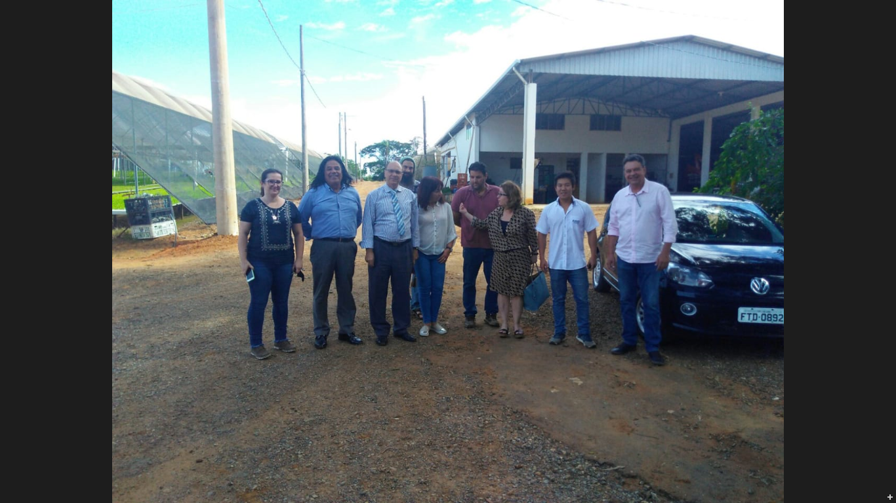
Figure 3. São Paulo ULL team with NGO “Good Partners”, producers and Ibiuna Secretary of Agriculture (Fernando Torre, next the car).
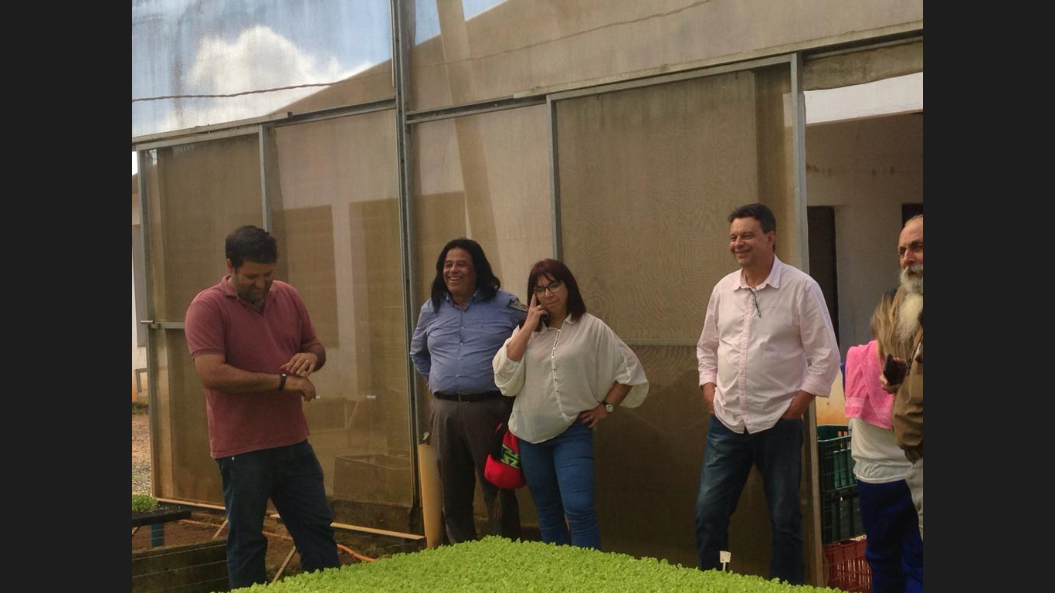Figure 4. Professor Barbara Teruel, São Paulo ULL team, Fernando Torre and horticulture producers, at Ibiuna.

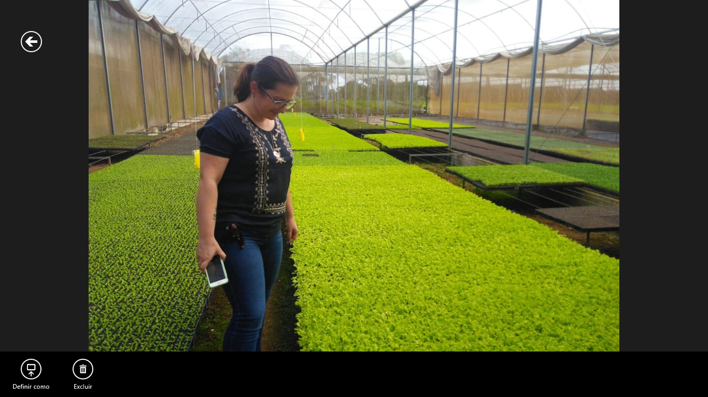
Figure 5. Erika Francisco, São Paulo ULL post doctoral researcher, at Ibiuna plantation.

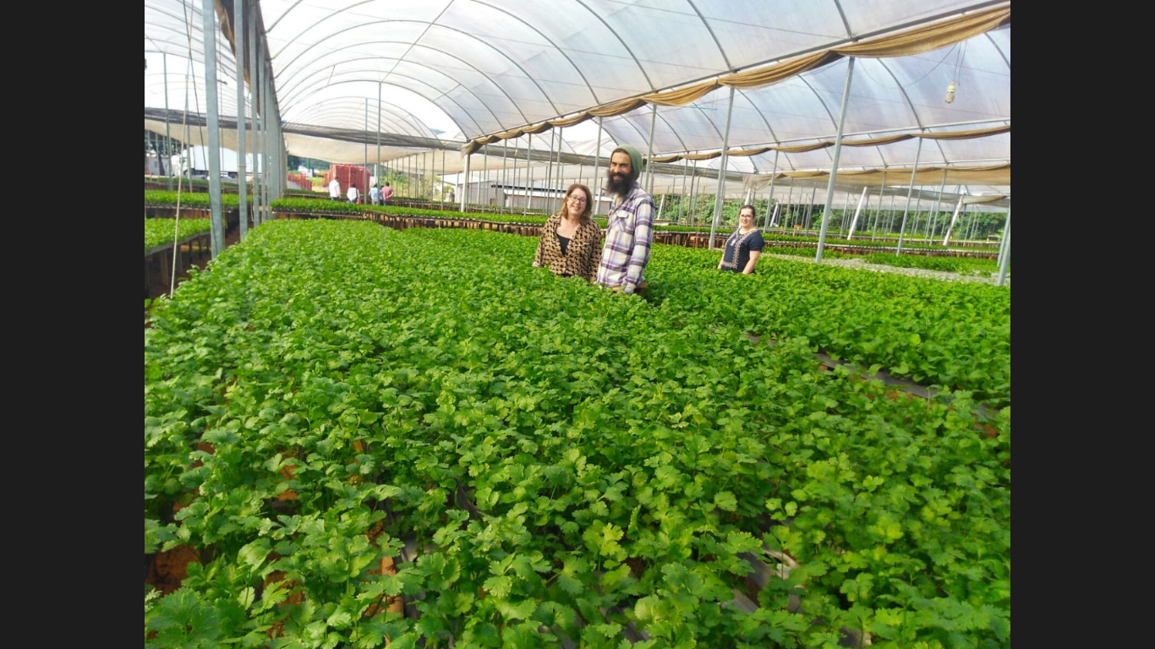
Figure 6. Ester Dal Poz, Erika Francisco and NGO agroecological partner, at Ibiuna plantation.

2. Actions concerning the academic work
Macro approach:
- Water-food production chains design (for the selected áreas) and sustainable business models – which will be offered for producers.
- Raw data resources: IBGE (Brazilian National Institute for Geography and Statistics) - Agricultural Census 2017, https://censos.ibge.gov.br/agro/2017/.
- Definition of theoretical and methodological approaches: Systems Dynamics and Agent Based Modelling; selection of simulation tools (Stella or Anylogics); “hard” data from IBGE and field work with producers; “soft” data from field work, with producers, NGOs and other stakeholders.
- According to the pipeline scheme: a) Seminar I (Feb the 4th), with transition theories and transition management tools; next seminar: ULLs institutional approach for WINIR 19 Conference; b) Seminar II (April, 2019), with methodological approach and causal loop validation.
Meso approach:
- Technical note 1. Sustainability global scenarios on food security and waste reduction, for the nexus governance ensamble (from the Lancet Comission 2019 article and from a broader literature)
- Technical note 2. Water and food management models
- Technical note 3. Horticultural water fingerprints models and methodologies
- Technical note 4. ULL communication project

