WASTE FEW ULL
WP5 | Impact Planning Update | June 2019

  - Introduction

The following sets out:

- Next steps in the lead up to the 2nd International Consortium meeting in Rotterdam
- Update on progress on impact planning from the Bristol ULL / WP5 Lead

By way of background, it also gives a quick overview of the following in the appendices:

- Appendix 1: Impact deliverables stated in the proposal
- Appendix 2: Clarifying types of impact

  - Next steps for impact planning – looking ahead to Rotterdam Sept 2019

WP Leads should by now have completed a stakeholder matrix (or used a tool of their preference) to start mapping out the key people and agencies in their unique problem space at local, regional and national level.
Action: Please prepare a short presentation on this for Rotterdam so that the rest of the Consortium can get a clear idea of your own unique ‘actor network(s)’ – there may be more than one network - and act as critical friend in developing it further.

We aim to gear up our impact planning and monitoring from September onwards – see below - and we suggest, in order to meet out anticipated deliverables, that each WP does likewise if they have not already done so.
Action: Please also therefore look at and consider the impact and monitoring templates* and complete a few worked examples to present to the consortium.

*These have been shared and uploaded on to SharePoint

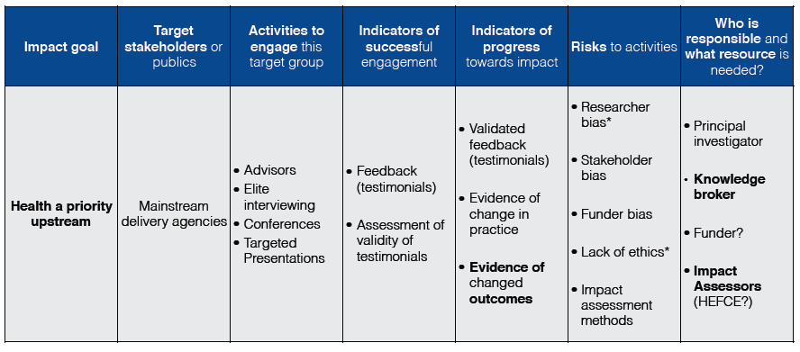
Fig 1: Example impact planning template from our UPSTREAM project
  - Progress to date on impact planning from the Bristol ULL

In October 2018 at the first International Consortium Meeting in Bath, UK, we set out a number of possible impact planning methods (road mapping, theory of change, four-phase model of trans-disciplinary research, and Fast Track Impact). We set out the fourth in more detail due to the simplicity of its three template tools, and we used these as stated deliverables in our proposal:

- Stakeholder analysis
- Impact Planning
- Impact Monitoring

In Bristol, we have completed a first pass stakeholder analysis based on the feedback of our three main ‘industry’ partners, who were recruited to the project based on a number of factors, including:

- Charitable or other socio-environmental mission-driven status
- Long and extensive experience locally
- Deep knowledge of the three subject areas (food, water, energy)
- End user status, or in-depth understanding of linked end user needs

Having ready access to these three agents is central to our approach. Though this approach has its limitations in the sense that the project is constrained from the start by those involved, the trade-off is that it should enable us to better satisfy the SUGI focus on solutions, and to fast-track problem solving. We discuss this tension – between solutions and inclusivity – below.

By engaging on multiple occasions with our three main partners over the first year, we were able to start identifying quickly key problems and user needs – N.B. not just their own needs given their charitable/social missions and interests, but based on their views - and to map out very early and in some detail the defined problem spaces (the actors, decision-makers, processes), and to target key stakeholders that are critically linked to the identified user need.

We subsequently carried out three focus groups/workshops targeted at those identified, which has enabled us to:

- Expand on the initial discussions with our primary partners with stakeholders identified as key contributors to the problem space
- Consider and discuss the wider system, linked actors and forces/drivers in more detail and from a range of broader perspectives
- Identify main areas of concern and delve deeper in to case study areas to explore actors, gaps in knowledge and likely barriers and opportunities
- Validate the optimal focus areas for preliminary test cases as part of the economic valuation
- Secure buy-in from key stakeholders in the growing Bristol WASTE FEW Urban Living Lab

We have yet had the opportunity – nor is the project sufficiently progressed (or resourced) - to sense-check this stakeholder analysis with the wider group identified. Still, it was a substantial exercise in its own right and a critical first step in our impact planning work. We were able to identify key linked stakeholders, who they are and what their primary aims are, their interests, their level of interest, their influence and level of influence. Figure 2 shows one snap shot of one of the three stakeholder matrices.

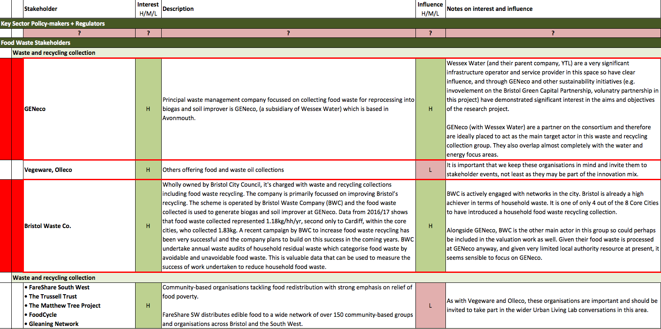
Fig 2: Example section of one of our three stakeholder analysis worksheets; this from the food worksheet

These stakeholder analyses also enabled us to produce basic graphical illustrations of each of the system areas for the city region – Figs 3-5 - which were used to communicate to stakeholder groups to the problem space. These graphics are not comprehensive models of the system and do not attempt to show its myriad interactions. Instead, they are simple graphical presentations of key actors in each system according to our industry partners to be used as first pass communication material for the purpose of the workshop and reporting. That said, they do suggest some interesting comparisons between the energy and water systems on the one side and the food system on the other, namely:

- Compared with the food system, the energy and water systems appear to have fewer, larger actors (e.g. large-scale, privately controlled infrastructure)

- The energy and water systems also appear to place government (e.g. BEIS, Treasury) and regulators (Ofwat, Ofgem) up front, whereas there is less clear national level governance influencing the food system.

Fig 3: Bristol’s key food actors - preliminary draft

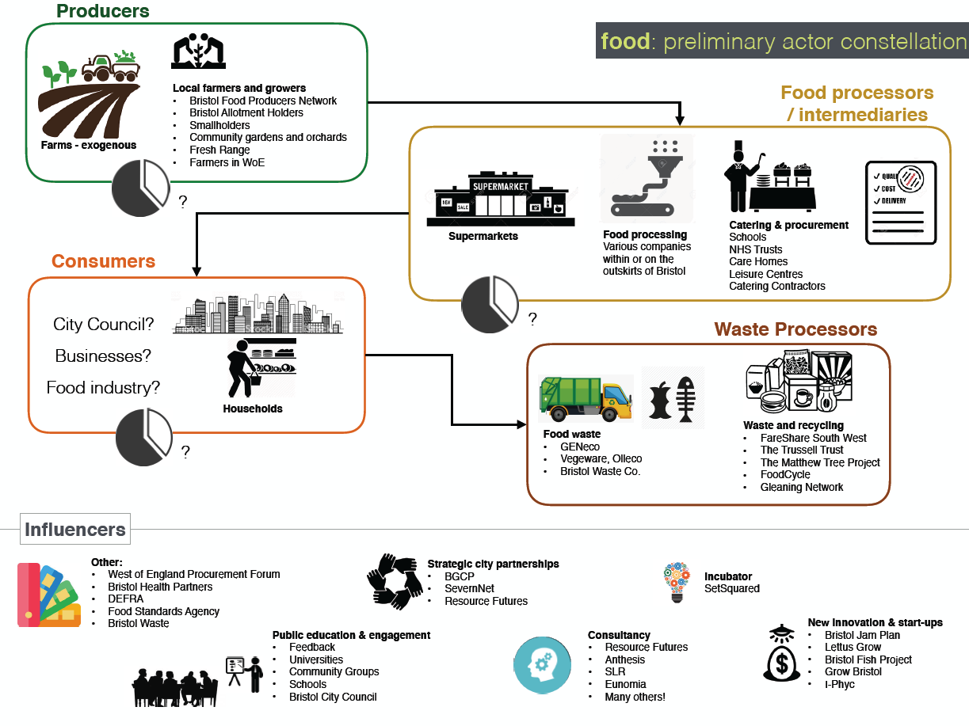

Fig 4: Bristol’s key energy actors – preliminary draft
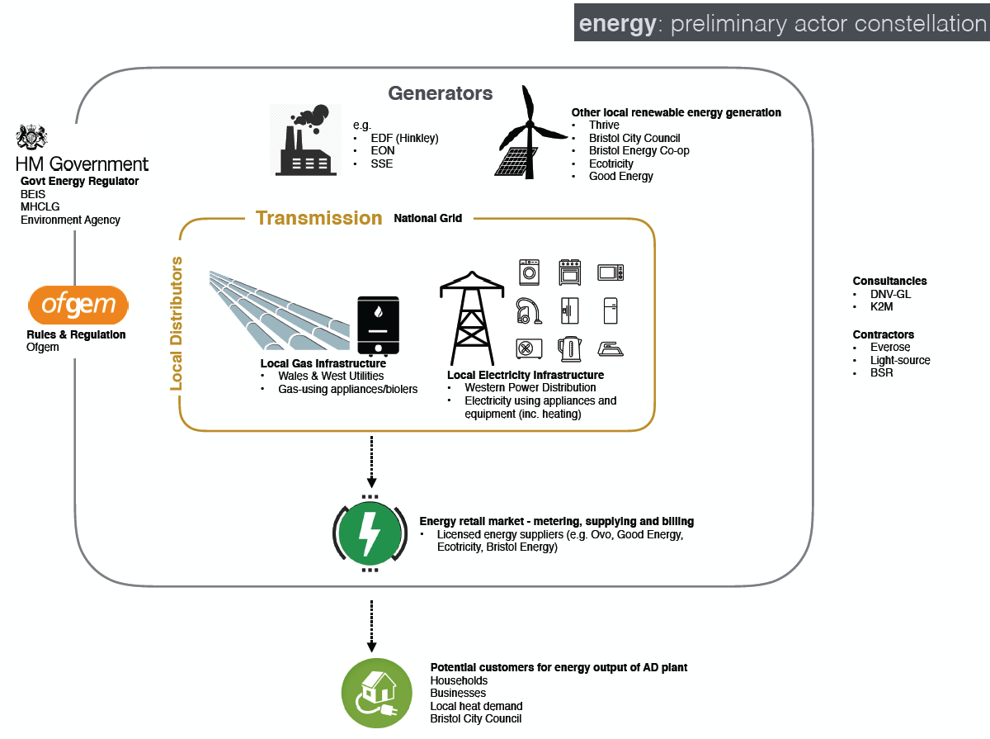
Fig 5: Bristol’s key water actors – preliminary draft

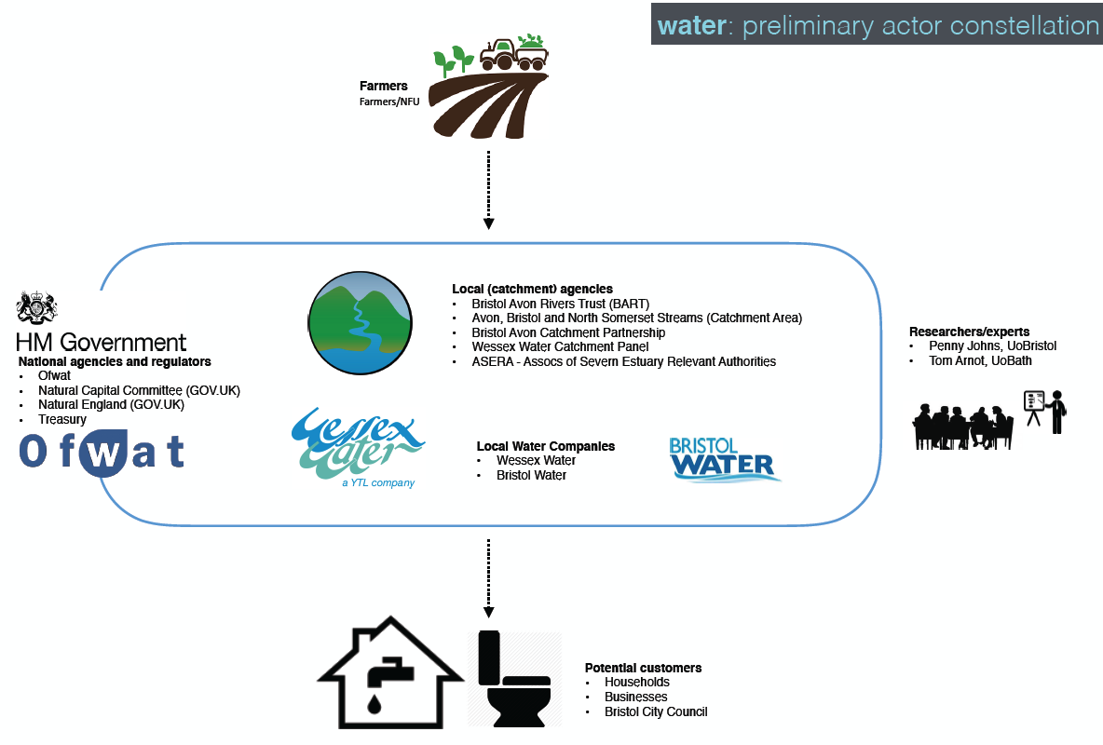

We had anticipated having a draft impact plan in place after the first six months, but in hindsight this was premature. While the workshops, which took place in March 2019, were broadly supportive of our three main partners’ positions, the analysis of those workshops is still ongoing.

We had also initially anticipated a more linear process that had systems modelling work following on from the workshops and feeding in to the economic valuation. Given project time and resource, and the need to progress with the economic valuation, we have decided to progress the analysis / systems mapping in parallel with the economic valuation. The intention now is to approach the economic valuation in two phases: 1) developing an initial conceptual worked example based on these early findings/directions from our core partners; 2) build a more comprehensive economic valuation model once the workshop analysis and the resource flow mapping has been undertaken.

As such, our conceptual model – Figs 5-6 - has changed subtly from one that illustrates the main focus areas and resource within the Bristol ULL with a linear flow from resource flow dynamics to economic valuation then decision-making, to one with a more clearly defined participatory engagement process, and with clearer flows from that activity through to concurrent and interacting activity in systems mapping/design thinking, economic valuation and resource flow modelling.

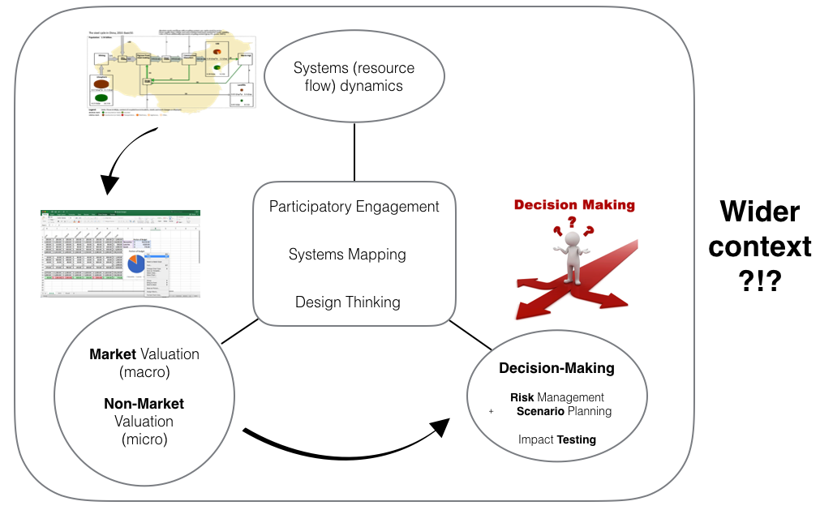

Fig 5: Initial conceptual activity flow
Fig 6: Emerging understanding of activities and flow after one year

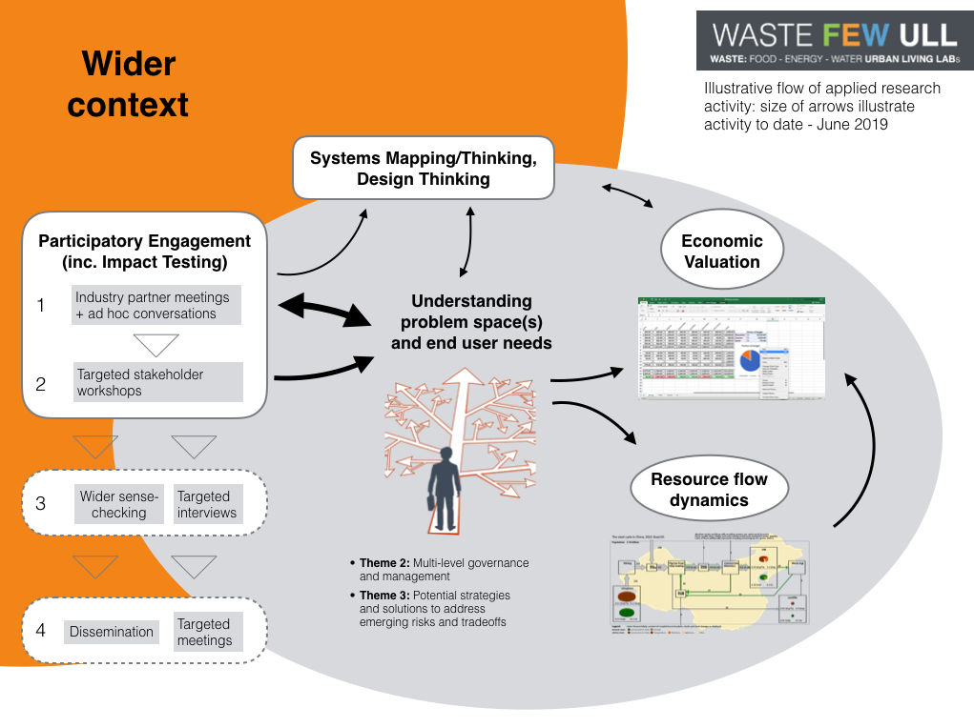

Appendix 1: Impact deliverables stated in proposal
Impact is a core activity that spans across all objectives and outcomes, but the two overarching that explicitly mention impact (in the sense of real world change) are:

- Objective 3: Agree likely pathways to impact in each context e.g. in UK and South Africa it may be disrupting waste flows through risk management; in Brazil and Netherlands it may be policy support for scaling of innovation

- Outcome 4: Evidence of impact: influence count of public outreach, behaviour change, policy take up

The main mechanism for impact planning and monitoring is WP5, but there are key components across all WPs (e.g. stakeholder analysis for WPs2-3) and in WP6 and 7 in particular.

WP 5 Objectives (as per original application)
Development of impact plan (target stakeholders, interests, activities, indicators, risks), co-created with consortium (to address different country contexts) and stakeholders (to ensure real world applicability) via workshops and additional liaison (email/phone/meetings); monitoring of impact activity (e.g. measurement indicator, progress, schedule of monitoring).

WP5 Description of work (as per original application)
This will be led by db+a from the UK Lead Team, but with all partners feeding in and responsible for their own impact strategies (beyond standard Pathways to Impact). db+a will be responsible for pulling together overarching impact work with UoSC/USA, and for leading collaborative review and testing of impact strategies.
1. Preparation of stakeholder analysis matrix, impact plan and impact tracking template by each partner
2. Agreement of impact materials and Impact plan (inc. policy briefings, targets) - ALL
3. Monitoring of impact plan
4. Final Impact report

WP 5 Deliverables (as per original application)
- Deliverable 4: Impact Plan (inc. stakeholder analysis and tracking document, policy briefings) – by 12/2018
- Milestone 2: Impact plan and all other project documentation ready and agreed – 12/2018
- Deliverable 17: Impact Report – March 2021

WP6 Objectives (as per original application)
- Presentation of evidence to relevant “power centres‟ to understand scope for change.
- Assessment of the potential for application of project to other cities globally.
- Agreement of future activity and next steps.

WP6 Description (as per original application)
Presentation of model to stakeholder groups in ULL workshop 3 and testing for impact

WP7 (as per original application)
Our approach to dissemination and outreach is fully integrated with the research programme through partnership with knowledge brokers and early and continuous impact planning and monitoring… UoSC will be leading the outreach and dissemination activities of the project, working in close partnership with the lead UK-team and knowledge broker, db+a, to ensure outreach links through to impact. They will have student support to assist in the delivery of the programme and will be supported in the US by a Steering Group that will sense-check strategies, activities and outputs to ensure they are targeted and impact is maximised.

UoSC, developed and delivered in regular consultation with UoC, will focus on impact, including: developing outreach strategies and activity plans; convening US-based steering Group; attendance at one annual event in each ULL; organisation of two conferences for consortium partners, one in the UK and another in South Africa (jointly with local ULL teams); development and supervision of PhD-led knowledge exchange forum; organisation of two early-career student-focused professional development workshops alongside the conferences; development and maintenance of project website; management and delivery of project outputs (policy briefing notes and other communication materials).

WP7 Objectives (as per original application)
Education workshops at each ULL, workshops and conference presentations targeted at key audience; preparation of policy briefings and other impactful materials for meetings; design of communication materials to present the project to diverse stakeholders; present targeted results, particularly the ULL co-created solutions on specific waste issues.

WP7 Description of Work (as per original application)
All lead country and work package partners responsible, but key responsibility lies with UoC, albeit with UoSC providing focused resource in this space.
- Design and deliver education workshops at each ULL to enhance FEW public literacy
- Development and updating of project website, blogs. Creation of online central register of dissemination opportunities (as part of impact plan) update on stakeholder analysis and compile information from all ULLs
- Drafting of policy briefing notes and other materials (e.g. videos, books, Coventry University’s Artist in Residence, presentations, reports)
- Conference opportunities on proposal, with update, findings, targeted dissemination and outreach activities agreed through impact plan and stakeholder engagement

WP7 - Dissemination and/or exploitation of project results, and management of intellectual property (as per original application)
- We are planning to use:
  - Newsletters
  - Web site
  - Blogs
- We will provide:
  - Training in workshops to practitioners and scientists at institutions of higher education so they could take a leading role in fostering FEW literacy as a means of preparing all global citizens for the FEW challenges. This will be targeted at diverse audiences (scientists, teachers, practitioners, NGOs, managers and city representatives), and will be offered at each ULL.
  - Educational resources combining the fundamental science of food, energy, and water with the skills and knowledge of interdisciplinary problem solving and the latest computational modeling and analysis tools and data. The materials will be based on student centered active learning, effective teaching strategies, and evidence-based practices. With this approach, we aim to promote knowledge of FEW nexus solutions that can foster new green and sustainable circular economies and hence contribute to the goals of the Sustainable

Other statements linked to impact

The Sao Paolo ULL refers to the “multi-criteria methods for assessment and evaluation of impacts”.

In the proposal we acknowledge the importance of real world impact – see Appendix 2 - when describing the innovative aspects of our proposal: “The emerging emphasis on real world impact in research (Greenhalgh et al, 2016) is echoed by the stated focus in this call on solutions.”

In describing the overall project type we say: “Our project is aimed at applying research in the real world to influence policy and to change the ways things are done. In other words, we are highly focused on producing impact via applied research”.

We describe our overall strategy as: “The overarching goal is for four city-regions across three continents to demonstrate that it is possible to identify the most pressing inefficiencies in their food-energy-water nexus, the most viable pathways to impact and to evidence impact and its future potential.”

Appendix 2: Clarifying types of impact
Though it may be well understood, it appears not often stated that real world impact and academic impact are different. As with the term ‘sustainability’ (i.e. economic sustainability does not always or often mean social or environmental sustainability), impact is often spoken off without qualification.

The LSE Handbook (2011) has a useful figure that illustrates this broad difference. It uses the term ‘external’ rather than real world and shows only two examples from each area: citations (academic) and influence counts (external). (Some academics object to the term ‘real world’, which suggests academics are separate from it. This itself is a subject of debate.)

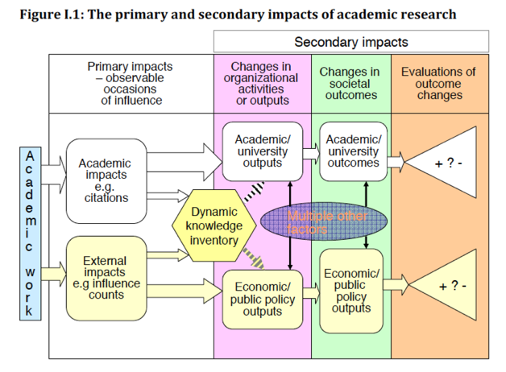
LSE Handbook (2011)

What the LSE Figure does not do however is to illustrate the very wide range of external impacts. It does not even suggest a differentiation between public sector/policy and private sector/practice. This is problematic in the realms of urban development where private sector practice – land control, financial investment, delivery of new infrastructure – dominates, and where public sector policy – planning policy, legislation – is either relatively weak or is proving ineffective.

Reed (2018) describes five different types of impact, without differentiating clearly between real world and academic, which nonetheless illustrate the breadth of potential impact:

- Instrumental impacts (e.g. actual changes in policy or practice)
- Conceptual impacts (e.g. broad new understanding/awareness-raising)
- Capacity-building impacts (e.g. training of students or professionals, CPD etc.)
- Attitudinal or cultural impacts (e.g. increased willingness in general to engage in new collaborations)
- Enduring connectivity impacts (e.g. follow-on interactions such as joint proposals, reciprocal visits, shared workshops, lasting relationships)
Reed (2018) also goes on to describe a variety of changes in the real world that one may be seeking to influence:

- Understanding and awareness
- Attitudes
- Economy
- Environment
- Health and wellbeing
- Policy
- Other forms of decision-making and behavior change
- Culture
- Other social
- Capacity or preparedness

The SUGI call (JPI Europe, 2019) states explicitly the types of changes that it is seeking to influence. Here follows a condensed list of those stated in the call, and which could be measured against when we seek to plan for and monitor external impact. Ours would likely include only some of the following.

- Security and social justice - increasing regional stress on urban food-water-energy
- Reciprocal and dynamic processes of urbanisation
- Physical movements of populations
- Build-up of city territories
- Transformation of economic structures
- Extension of suburban sprawl and re-urbanisation
- Material and energy use
- Land-use transformations
- Resource-intensive behaviours and consumption
- Impacts on ecosystem services
- Changes driving social and cultural inequities
- Balancing trade-offs
- Resilience
- Climate compatibility
- Sustainable Consumption and Production (SCP)
- Comprehensive spatial perspectives
- Multi-level governance strategies.
- Synergies between sectors (“silos”) and fields commonly seen apart in business, policy and research:
- Urban governance, planning, and management
- Socio-economic development and cohesion
- Grey, green, and blue infrastructures

  - References

- LSE Public Policy Group (2011) Maximising the impacts of your research: A handbook for social scientists. Available from: https://blogs.lse.ac.uk/impactofsocialsciences/the-handbook/
- Reed M (2018) The Research Impact Handbook. Available from: https://www.fasttrackimpact.com/research-impact-book
- Davies et al (2005) Assessing the impact of social science research: conceptual, methodological and practical issues. A background discussion paper for ESRC Symposium on Assessing Non-Academic Impact of Research.
- JPI Europe (2019) Sustainable Urbanisation Global Initiative (SUGI)/Food-Water-Energy Nexus. Available from: https://jpi-urbaneurope.eu/calls/sugi/

Our main criticism of the Fast Track Impact approach – and academia more generally - is that it doesn’t appear to account for the expertise and experience of the people undertaking the impact planning work, which can have an enormous influence on quality. (There are also questions around the tensions between solutions and inclusivity, which we seek to debate in the appendices).

